Name: _____________________________________ Due: 9/25 Points: _____/ 28
English I: 9/21-9/25
Essential Questions:
- Story Structure: How do we put our reader in a specific moment in our writing?
Week Goals
- World Cultures: Look through the eyes of a Vietnam soldier and try to understand his experiences.
- Grammar: Apply the first 4 Comma Rules in your own writing
- Writing:
  - Put your reader in a specific moment in time through action verbs.
  - Start your memoir as close to the conflict as possible (today’s the day)
  - Use the story arch (conflict, rising action, climax, falling action, resolution) in your memoir.
 | Agenda | Tentative Homework
Monday 9/21: Read out our memoirs | - Do-Now: Share out best paragraphs from The Things We Carried memoirs  - Pass out TTTC books  - Read “Love” and “Spin” | - Read “Love” and “Spin”  - Answer the “Love” and “Spin” questions (in packet)
Tuesday 9/22: What is the story arch? | - Do-Now: 8 Comma Rules (do first 4)  - Discuss last night’s homework  - Read “On the Rainy River” in class  - Complete the Story Graph  - Answer the questions | - Complete “Story Graph” (in packet)  - Answer the “On the Rainy River” questions (in packet)
Wednesday 9/23: Why use the story arch? | - Do-Now: Creative Writing Prompt  - Discuss last night’s homework  - Introduce Memoir Prompt #2  - Brainstorm ideas for memoir prompt #2 | - Write an outline of your memoir following the story arch
Thursday 9/24: Writing an intense memoir | - Do-Now: 8 Comma Rules (apply first 4 rules to “The Things We Carry” memoir)  - Share out story outlines  - Time to write your memoir. | - Write a rough draft of the memoir.
Friday 9/25: What did we learn this week? | - Quiz  - First 4 Comma Rules  - Know Story Structure (conflict, rising action, climax, falling action, resolution)  - Know the difference between “action” verbs and “being” verbs  - Share best and worst parts of memoir draft | - Turn in this packet to Ms. Janna

Memoir Prompt #2: Story Structure
- Write a story about your loved one. It must be about the following:
  - An important moment, a life-changing moment (Today’s the day…).
  - One specific moment in time (something that happened over the course of an hour)
    - Use the story arch structure (conflict, rising action, climax, falling action, resolution)
- Write this memoir on the Mixed Tape Autobiography
- Use “active” verbs over “being” verbs.
  - Action verbs = action = run, illuminate, stab, carry, shroud, tremble = she ran across the field
  - Being verbs = being/existing = is, feels, appears, seems = she is happy, he feels sad, she is a woman.

Annotations “Love,” “Spin,” and “On the Rainy River”
Page # | Summary
26
27
28
29
30
31
32
33
34
35
36
37
38
39
40
41
42
43
44
45
46
47
48
49
50
51
52
53
54
55
56
57
58

“Love” and “Spin” Questions Points: ____/ 10

- Did your opinion of Jimmy change after reading “Love”? Why or why not? (2 points)

- In the chapter “Spin,” O’Brien writes, “What sticks to memory, often are those odd little fragments that have no beginning and no end” (34). What story from this chapter impacted you the most and why? (2 points)

“On the Rainy River” Questions
- Why does O’Brien say at the end of the chapter, “I was a coward. I went to the war” (58)? Use one quote from the book to support your opinion. (2 points)

- Where was the most intense part of this chapter? Why was this part intense? Use one quote from the book to support your opinion. (2 points)

- O’Brien structured “Spin” and “On the Rainy River” very differently. “Spin” contains these small, fragmented stories while “On the Rainy River” is about one, specific memory that follows the story arch perfectly (conflict, rising action, climax, falling action, resolution). In your opinion, which structure is more effective in getting your reader to feel emotion? (2 points)

“On the Rainy River” Story Arch Points: ___/5
Directions: Plot out the main events from the chapter, “On the Rainy River” on the story arch below. Our goal is to see how O’Brien structured this story in a way that held his readers’ attention.

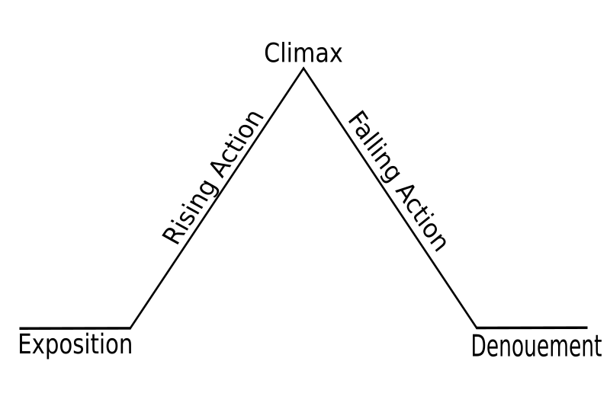

Your Memoir Story Arch Points: ___/5
Directions: Plot out your memoir on the story arch below.

The 8 Comma Rules Points: ___/8
Directions: After each rule and example, identify the subject and predicate. Then, add commas to the sentences where needed.
- Commas for Quotations
  - Rule: Use a comma to separate a quotation from the rest of a sentence.
    - Example: “We must buy more sugar” she said “before it runs out!”
“We must buy more sugar,” she said, “before it runs out!”
  - Practice:
    - “I am tired” he muttered.
    - He said “We need to lower taxes!”
    - “If I don’t wake up in time” he whispered “I will be in trouble.”
    - “Today will be rainy” the weatherman said with a frown.
    - The boy watched his mother and wondered “Could I ever be that strong?”
    - “Okay” spoke the teacher excitedly “Time’s up!”

- Commas for Coordinating Conjunctions
  - Rules: Use a comma to separate independent clauses (complete thoughts) when they are joined by the following conjunctions:
      - For, And, Nor, But, Or, Yet, So (FANBOYS)
    - Example: I want to buy the new jacket but it is too expensive. (incorrect)
I want to buy the new jacket, but it is too expensive. (correct)
  - Practice:
    - We can go to the zoo or we can go to the movie theater.
    - They like chocolate but they like vanilla better.
    - We will go to the restaurant now for we are very hungry.
    - I do not like biology nor do I like chemistry.
    - James wants to leave now yet we must wait for his little brother.
    - Terry is working on a project and he should be finished with it next week.

- Commas for Dependent Clauses
  - Rules:
    - Use a comma to separate a dependent clause (incomplete thought) from an independent clause (complete thought) when the dependent clause comes first.
    - Examples:
      - She is my friend because she drives a corvette.
(Independent) (Dependent)

      - Because she drives a corvette, she is my friend.
(Dependent) (Independent)

    - Example: Without water the plant will die. (incorrect)
Without water, the plant will die. (correct)
The plant will die without water. (correct)
  - Practice:
    - In five minutes the building will be closed.
    - When I get home I am going to brush my teeth.
    - Until I reach my goal I will not stop working.
    - If I get a new job I will be very happy.
    - To become an astronaut it takes much hard work and determination.
    - Because she is only twelve she is not old enough to drive.

- Commas for Introductory Elements
  - Rule: Use a comma to separate an introductory element from the rest of a sentence.
    - Example: Hi how are you? (incorrect)
Hi, how are you? (correct)
  - Practice
    - Yes I would like more water please.
    - Sorry we do not have enough room.
    - Well I hope the problem will be fixed soon.
    - However I am very good at math.
    - Wait is there another way?
    - Unfortunately we do not have enough time.

- Commas for Lists
  - Rule: Use commas to separate items in a list of three or more. Remember that an “item” may refer to a noun, verb, or adjective phrase.
    - Example: I need to buy eggs and milk. (correct—just two items)
I need to buy eggs milk lettuce and bread. (incorrect)
I need to buy eggs, milk, lettuce, and bread. (correct—commas for 3 or more)
  - Practice:
    - Carlos wants to visit Paris Italy Germany and China.
    - My favorite colors are blue red and pink.
    - I like to go hiking fishing swimming and camping during summer.
    - I have to clean my room walk the dog and take out the trash.
    - The tree is very tall old and green.
    - I need to visit my mother wash my car and buy six stamps.

- Commas for Nonessential Information
  - Rule: Use a comma(s) to separate any word or phrase from the rest of the sentence that is not essential to the sentence's meaning.
    - Examples:
      - My brother, a 26 year old male, is watching TV.
      - Amy Rivers, my best friend, is going to the mall today.
      - I am ready for my dad, a hard working man, to come home.
    - Example: My mother on the other hand does not like chocolate. (incorrect)
My mother, on the other hand, does not like chocolate. (correct)
  - Practice:
    - Daniel Garrison a farmer wakes up very early.
    - Tanner my teacher is wearing a gray shirt.
    - The car a 1967 Ford Mustang is very fast.
    - Gold watches for example are going on sale today.
    - My favorite color navy blue is very popular.

- Commas Separating Cities from States or Countries
  - Rule: Use a comma to separate the name of a city from a country or state.
    - Example: I live in Chapel Hill North Carolina. (incorrect)
I live in Chapel Hill, North Carolina. (correct)
  - Practice:
    - We are moving to Spokane Washington.
    - I visited Florence Italy last summer.
    - The hurricanes hit Tulsa Oklahoma and Destin Florida.

- Commas for Dates
  - Rules:
    - Use a comma to separate the day of the week, the day of the month, and the year.
    - Example: Today is Thursday April 18 1943.
Today is Thursday, April 18, 1943.
  - Practice:
    - Tomorrow will be Sunday December 2nd.
    - George Washington was born on February 22 1732.
    - I will be sixteen on Tuesday the 6th of July 1582.
    - September 11 2001 is a date that will be remembered.

Name: ___________________________________

Daily Summary: “Enemies” and “Friends”
Plot (2 points):
● What happened? Write four events that occurred in this reading.

Significant Quote (2 points):
- Write down one significant quote from the pages you just read.
- Interpret the quote: what does this quote mean? What is the quote saying?
- Write two to three sentences on why this quote stood out to you. Consider discussing how it revealed a personality trait in a character, how it hit upon an important idea, how it reminded you of a past experience you’ve had, etc.

Daily Summary: “How to Tell a True War Story”
Plot (2 points):
● What happened? Write four events that occurred in this reading.

Significant Quote (2 points):
- Write down one significant quote from the pages you just read.
- Interpret the quote: what does this quote mean? What is the quote saying?
- Write two to three sentences on why this quote stood out to you. Consider discussing how it revealed a personality trait in a character, how it hit upon an important idea, how it reminded you of a past experience you’ve had, etc.

