Dia de los Muertos Project:
The Things We Remember
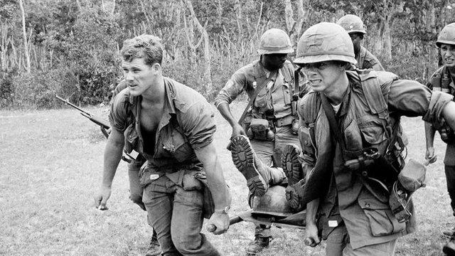
Essential Question:
- When memories are faulty, when people’s understanding is lacking, what does it mean to be truthful when retelling an experience from our past? How do we most accurately and effectively convey an important experience to another human being?
- How is the way a pinhole camera captures an image on photo paper similar and different from the way our minds capture and remember experiences?
Project Overview:
- Students will examine the essential role that memories play in Dia de los Muertos: how people are comforted by the idea of having their loved ones honored and remembered.
- Students will read The Things They Carried in order to identify how O’brien portrayed his memories in the most accurate effective way that he could while telling lies or embellishing the truth. They will identify how he attempted to honor these men with this book.
- Students will attempt to find the most effective way of honoring and remembering their own loved ones by responding to a variety of writing prompts, bringing in items from their past, drawing and taking photos in an effort to discover the most effective way of conveying an experience to another human being.
Texts:
- The Things They Carried by Tim O’Brien
- “Eleven” by Sandra Cisneros
- “The Whore’s Child” by Richard Russo
- “Bullet in the Brain” by Tobias Wolff
- How Stuff Works: Memories
- “Superman” by Sherman Alexie
Product:
- A collection of attempts at conveying memories
  - Brief memoirs as responses to writing prompts
  - Objects from their past
  - Photos taken to reconstruct memories
  - Drawings of memories
- A refined version of a chosen memoir.
- An artist statement describing how the photo compliments the memoir

