Assignment Prompts for Exhibition Task List

Da Vinci Entry #1: Vision

The purpose of this journal entry is to have you spend some time thinking about the process your brain goes through in order for it to sense and perceive (make sense of) what’s going on around you.

On a plain sheet of paper (no lines) do the following:

- Draw the neural process that takes place in order for your brain to sense and make sense of the visual world around you.
- Annotate your drawing to describe the parts of the eye, the optic nerve, and the parts of your brain that receive and process different pieces of information
- In your annotations, include the questions you have about this process, how this process relates to the soldiers’ experiences in The Things They Carried, or how it makes you understand your own experiences of sensation and perception differently.

Remember: Take your time. Look at the image below. Notice the amount of text and the quality of the drawings. Don’t just draw to draw or write to write. Instead, make something beautiful.
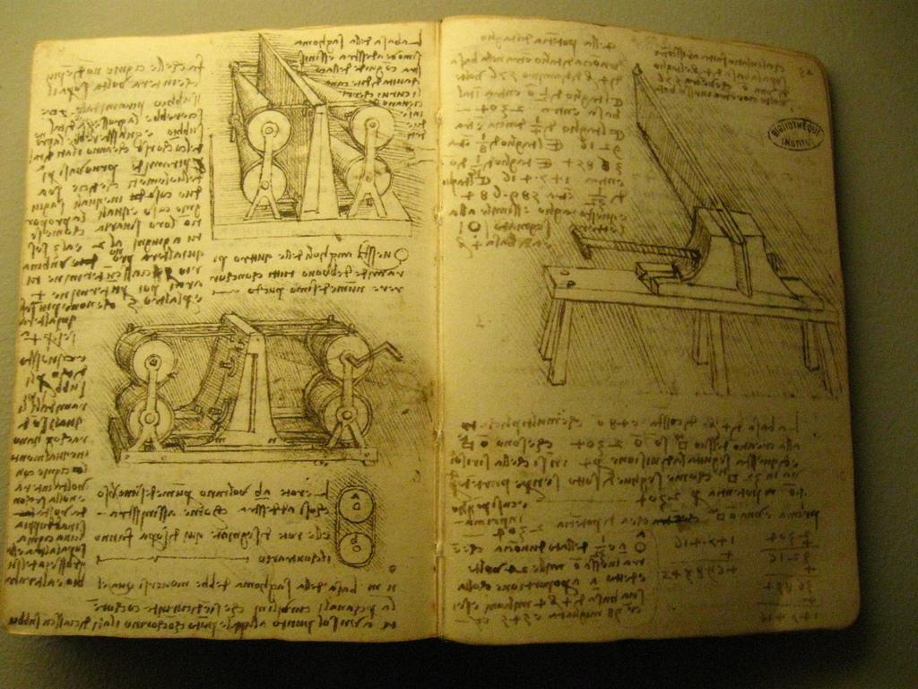
- If you want an alternative, print images from the web, then cut them out and paste them onto your journal page with annotations describing what these images are and how they represent that neural process. DON’T, I REPEAT DON’T, JUST COPY AND PASTE AN IMAGE OF THE NEURAL PATHWAY FROM EYE TO BRAIN AND CALL IT A DAY. Instead, make sure that your annotations include questions, comments, hypotheses, concerns, confusions.

Da Vinci Journal Entry #2: Photo

Directions: What could you take a photo of that would represent the person from your memoir? Create two ideas for photos and draw them on a separate sheet of 8.5x11 blank paper. Label the two drawings with explanations on how these images would capture the person from your memoir.

Da Vinci Journal Entry #3: The Truth

Unit EQ: When memories are faulty, when people’s understanding is lacking, what does it mean to be truthful when retelling an experience from our past? How do we most accurately and effectively convey an important experience to another human being?

Throughout our reading of The Things They Carried, I heard a lot of different ideas on how you think an author should convey the truth of a memory. In this da Vinci journal entry, I want you to think about what truth is in a memoir. Use the statements below as a guide into your own beliefs on the matter.

  - “The truth is in the facts. The author should only tell what he knows from the memory and nothing else.”
  - “The truth is in the facts but also in the emotions behind the facts. The author has a right to add a few details to the story to convey the emotions he felt, but ultimately he must tell the truth as he remembers it.”
  - “The truth is in the emotions. The author has complete freedom to change the people, events and details and still call it the truth, so long as it makes the reader feel what the author felt.”

Once you think about your idea of truth, answer the following questions in your da Vinci entry:

- What does it mean to be truthful when writing a memoir? WHY do you feel this way? How has O’Brien’s novel influenced your thinking?

- Images are a great way to spark a new way of thinking about a topic. Find an image that best conveys your idea of truth. Draw that image or paste one from online like the ones I found below. Then, explain what is it about your image that best conveys your idea of truth.

- How have you tried to employ this idea of truth in your own memoir? Choose one quote from your own memoir where you think you employed truthfulness.
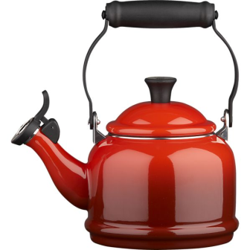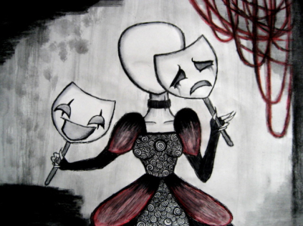

Da Vinci Journal Entry (Extra Credit): Remembering

- How does remembering work? In a previous da Vinci journal entry, you wrote about sensation and perception (how the information gets into your brain). This time, I want you to write and draw how you store and retrieve this information.

  - How do you store memories? Write down the process of storing memories. Be sure to mention what part of the brain is involved.
  - How do you retrieve memories? Write down the process of retrieving memories. In what part of the brain does that happen?
  - How is memory faulty? Can memories be manipulated, changed or completely lost? When and why does that occur?
    - For all of the questions above, use these websites to gather information or feel free to conduct your own research:
      - http://science.howstuffworks.com/life/inside-the-mind/human-brain/human-memory.htm
      - http://www.bbc.com/future/story/20140221-how-does-your-memory-work
      - Crash Course (Youtube Videos)
        - https://www.youtube.com/watch?v=bSycdIx-C48
        - https://www.youtube.com/watch?v=HVWbrNls-Kw

- How does this connect to the following:

  - How does this process relate to your own memories and the memoirs you are writing?
  - How does this process relate to Dia de los Muertos?
  - How does this process relate to the process of taking photos?

- What are three images could you include in this journal that would help illustrate the ideas you wrote about above? How would they relate?

TTTC Final Reading Reflection

1. On the lines below, write a ¾ page to a full-page reflection on your personal reaction to The Things They Carried. Consider discussing the following:
a. What emotions did you feel while reading the book?
b. Which characters and scenes did you most relate to?
c. Which characters or scenes remain strange or difficult to comprehend?
d. Was the resolution of the book satisfying? Comforting? Disturbing? Why?
e. How does this book relate to Dia de los Muertos? What connections can you make?

The Things They Carried Memoir Prompt #1

Prompt: What do you or someone you love carry?

Directions: Write a one page memoir on the everyday objects that you or someone you love carries with them in order to honor the person that they are. Like in Tim O’brien’s first chapter, write about the concrete objects that you or this person carries with them on a daily basis, as well as the emotions and ideas that you carry with you. For each object/idea/emotion, describe in detail using physical descriptions, memories associated with these objects, and explanations for why these objects are important. See my example below for ideas.

Remember that this first draft is your pen vomiting words onto a blank white page. Vomit all over the page. Make it drip with word vomit, meaning write whatever comes to your mind in response to the prompt. If this is a prompt that captivates you, we’ll refine it later for the Dia de los Muertos exhibition, so don’t worry just yet about it being perfect. This is your place to experiment and try random ideas out.

For those students who like requirements and structure:
- For each object you describe, use the sentence starter:
  - He/she/I carried _____________________________________.

- Include 3 tangible objects using multiple adjectives describing that object’s physical characteristics.
  - Example: She carried red, glossy nail polish that she was saving for a special occasion

- Include 3 intangible objects. For each intangible object, explain what that intangibleness looks like in that person’s life.
  - Example: I carry anxiety. I fidget a lot. I can’t keep my arms still. I bite my nails, pull my hair, pick my scabs. If you held me, I’d probably feel like a bird in your hands. Wings twitching to take off and fly.
  - Example: I carry my thoughts. I’m always thinking, except when people actually think that I‘m thinking, and ask me what’s on my mind. Then I always seem to be fresh out of ideas to share. Usually my thoughts during the morning drive are on the day ahead, on the students I’ll see.

For those who don’t like requirements and feel your creativity is being stifled by Ms. Janna’s over-planning, just provide a mixture of tangible and intangible objects that you think best conveys that person you’re trying to describe to your reader.

Friday 9/26: Memoir Prompt #2: Love, Spin or Rain

Directions: As discussed in class, and mentioned by O’Brien in his interview, each chapter of the book can stand alone (as a story in and of itself). This week, we’ve been using his chapters as models for creating our own memoirs. For the Do-Now writing prompts that you started in your journal, expand upon ONE of these to create a full page memoir. Try incorporating the rhetorical strategies we’ve been discussing in class, such as imagery, metaphor, symbols and selection of detail.

- Love: Write about a time when you showed someone or told someone that you love them. Or, write about a time when someone showed or told you that they love you. What was the context of this event? Where did this take place (setting)? How did you and they react? What happened next?

- Spin: In this chapter, O’Brien reflects upon the year he spent in Vietnam. Some of his memories are just flashes of images. Others are strings of stories. Write about an entire year in your past. What do you remember from that year? Write about the fragments of memory, those flashes of images like a camera, as well as the narratives that you remember.

- On the Rainy River: In this chapter, O’Brien shares how he made the difficult decision to go to war rather than flee to Canada. Write about a time when you felt torn between one decision and another. What was the decision? Think about how O'Brien leads us through this chapter, unveiling his deepest fears to his readers. Try to be as honest as O’Brien in your own memoir.

Prompt for Memoir #3: Intensity

Directions: Write a one-paged memoir on the following prompt. You may type your memoir or handwrite it. See my example below (it’s depressing though, so watch out).

- This week, we have been focusing our attention on how O’Brien gets our senses involved and how those senses lead to an intense emotional response. We’ve been discussing the process of perception and how our minds make meaning of the world around us. For your memoir this week, tell the story of the most intense moment in your life. Try to use all five senses (imagery) in your story. Be aware of the details you choose to include (selection of detail) and how those details are enhancing or detracting from the story.

